**12. IEEE floating-point formats.**

In the 32 bit **IEEE format**, 1 bit is allocated as the sign bit, the next 8 bits are allocated as the exponent field, and the last 23 bits are the fractional parts of the normalized **number**. A sign bit of 0 indicates a positive **number**, and a 1 is negative.

metin içeren bir resim

Açıklama otomatik olarak oluşturuldu

metin içeren bir resim

Açıklama otomatik olarak oluşturuldu

metin içeren bir resim

Açıklama otomatik olarak oluşturuldu

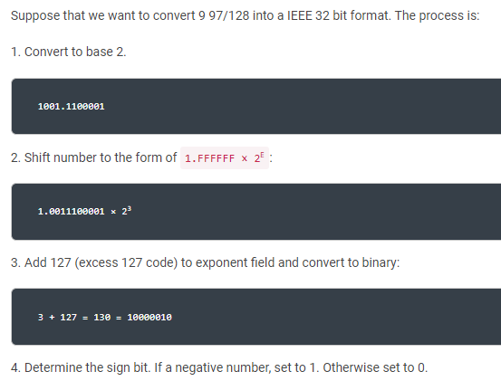

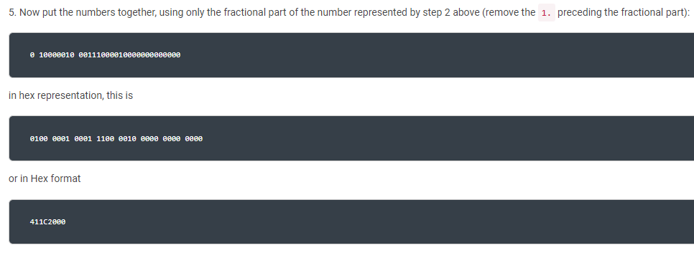

**13. Double-Precision floating-point format.**

***Double- Precision Floating-Point Format***

The double-precision format helps overcome the problems of the singleprecision

floating-point. Using twice the space, the double-precision format

has an 11-bit excess-1,023 exponent and a 53-bit mantissa (including an

implied HO bit of one) plus a sign bit. This provides a dynamic range

of about 10± **308** and 14 1/2 digits of precision, which is sufficient for most

applications.

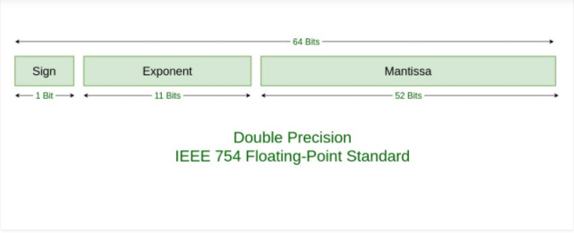

**14.Single-Precision floating-point format.**

**Single**-**precision floating**-**point format** (sometimes called FP32 or float32) is a computer **number format**, usually occupying 32 bits in computer memory; it represents a wide dynamic range of numeric values by using a **floating** radix **point.**

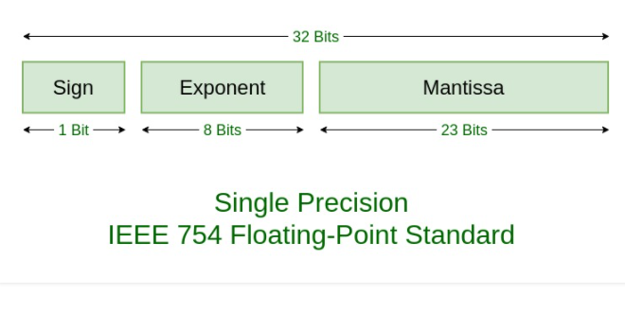

**EXAMPLE**

**metin içeren bir resim

Açıklama otomatik olarak oluşturuldu**

**metin, su kuşu, ekran görüntüsü içeren bir resim

Açıklama otomatik olarak oluşturuldu**

**15. Moore’s Law**

Moore’s Law is a theory about the availability of transistors on integrated circuits. In 1965, [Intel](https://www.webopedia.com/definitions/intel/) co-founder Gordon Moore observed that the number of [transistors](https://www.webopedia.com/definitions/transistor/) per square inch on an [integrated circuit](https://www.webopedia.com/definitions/integrated-circuit-ic/) had doubled each year since its invention. Moore predicted that this trend would continue until the mid-2020s. The process of adding transistors involves shrinking the relative size of each transistor by half to create room rather than increasing the size of the circuit itself. This is why [computer](https://www.webopedia.com/definitions/computer/) engineers have been able to create devices over time that are simultaneously smaller and more powerful than their predecessors.